**FIRE DETECTION USING**

**FLAME SENSOR**

**~Submitted by**

### **Team Members**

1. G, Naveen Reddy(21911A3517)
2. G. Suhas (21911A3518)
3. G. Sri Charan Reddy (21911A3519)
4. I.Omkar(21911A3520)

### **Introduction**

Fire safety is a critical aspect of modern living and industrial environments. Early detection of fire can prevent catastrophic damage, save lives, and minimize economic losses. The Fire Detection and Suppression System project leverages an Arduino Uno microcontroller, a flame sensor, and other electronic components to create an efficient and cost-effective solution for detecting fires and initiating a response.

In this project, a flame sensor is used to detect the presence of a fire. When a fire is detected, the Arduino Uno triggers an alarm through a buzzer and activates a 5V DC water pump via a relay module to suppress the fire. The system is powered by a 9V DC battery for the Arduino and a 5V AC-DC adapter for the relay and pump, ensuring reliable operation.

### **Components**

• Arduino Uno

• Flame sensor

• 5V relay module

• 5V DC water pump

• Buzzer

• 5V AC-DC adapter

• 9V DC battery

• Breadboard

• Male jumper wires

• Connecting cables

**Circuit Diagram**

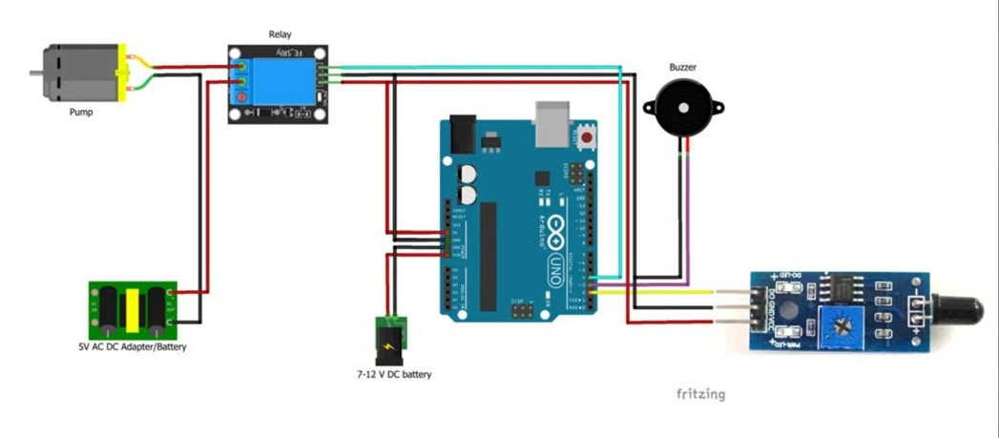

### **Source Code**

#define SENSOR_PIN 2

#define BUZZER_PIN 3

#define RELAY_PIN 4

#define SPRINKLER_START_DELAY 5000

#define SPRINKLER_ON_TIME 3000

unsigned long previousTime = millis();

void setup()

{

pinMode(RELAY_PIN, OUTPUT);

pinMode(SENSOR_PIN, INPUT);

}

void loop()

{

//If there is fire then the sensor value will be LOW else the value will be HIGH

int sensorValue = digitalRead(SENSOR_PIN);

//There is fire

if (sensorValue == LOW)

{

analogWrite(BUZZER_PIN, 50);

if (millis() - previousTime > SPRINKLER_START_DELAY)

{

digitalWrite(RELAY_PIN, LOW);

delay(SPRINKLER_ON_TIME);

}

}

else

{

analogWrite(BUZZER_PIN, 0);

digitalWrite(RELAY_PIN, HIGH);

previousTime = millis();

}

}

### **Procedure:**

1. **Connect Components:**
   * Flame Sensor: VCC to Arduino 5V, GND to GND, OUT to digital pin D2.
   * Relay Module: VCC to Arduino 5V, GND to GND, IN to digital pin D3.
   * Buzzer: Positive to digital pin D4, Negative to GND.
2. **Set Up Power and Relay Circuit:**
   * Relay to Pump: NO terminal to one pump terminal, COM to negative of 5V adapter, other pump terminal to positive of 5V adapter.
   * Arduino Power: 9V battery to Arduino's VIN and GND.
3. **Write and Upload Code:**
   * Open Arduino IDE, copy the provided code, connect Arduino to computer, and upload the code.
4. **Assemble and Verify Connections:**
   * Secure all components on the breadboard, ensure connections match the wiring diagram, power the system using the 9V battery and 5V adapter.
5. **Test the System:**
   * Activate the system, introduce a flame near the sensor to test, confirm buzzer and pump activate, remove flame to ensure system resets.